**Linux Unhatched**

Arguments

command [options…] **[arguments…]**

An argument can be used to specify something for the command to act upon. The ls command can be given the name of a directory as an argument, and it will list the contents of that directory. In the next example, the Documents directory will be used as an argument:

**sysadmin@localhost:~$** ls Documents

School alpha-second.txt food.txt linux.txt os.csv

Work alpha-third.txt hello.sh longfile.txt people.csv

adjectives.txt alpha.txt hidden.txt newhome.txt profile.txt

alpha-first.txt animals.txt letters.txt numbers.txt red.txt

The resulting output is a list of files contained with the Documents directory.

Because Linux is open source, there are some interesting secrets that have been added by developers. For example, the aptitude command is a package management tool available on some Linux distributions. This command will accept moo as an argument:

**sysadmin@localhost:~$** aptitude moo

There are no Easter Eggs in this program.

There is more to this trick than meets the eye, keep reading!



Options

command **[options…]** [arguments…]

Options can be used to alter the behavior of a command. On the previous page, the ls command was used to list the contents of a directory. In the following example, the -l option is provided to the ls command, which results in a "long display" output, meaning the output gives more information about each of the files listed:

**sysadmin@localhost:~$** ls -l

total 32

drwxr-xr-x 2 sysadmin sysadmin 4096 Aug 4 20:58 Desktop

drwxr-xr-x 4 sysadmin sysadmin 4096 Aug 4 20:58 Documents

drwxr-xr-x 2 sysadmin sysadmin 4096 Aug 4 20:58 Downloads

drwxr-xr-x 2 sysadmin sysadmin 4096 Aug 4 20:58 Music

drwxr-xr-x 2 sysadmin sysadmin 4096 Aug 4 20:58 Pictures

drwxr-xr-x 2 sysadmin sysadmin 4096 Aug 4 20:58 Public

drwxr-xr-x 2 sysadmin sysadmin 4096 Aug 4 20:58 Templates

drwxr-xr-x 2 sysadmin sysadmin 4096 Aug 4 20:58 Videos

Often the character is chosen to be mnemonic for its purpose, like choosing the letter *l* for *long* or *r* for *reverse*. By default, the ls command prints the results in alphabetical order, so adding the -r option will print the results in reverse alphabetical order.

**sysadmin@localhost:~$** ls -r

Videos Templates Public Pictures Music Downloads Documents Desktop

Multiple options can be used at once, either given as separate options as in -l -r or combined like -lr. The output of all of these examples would be the same:

ls -l -r

ls -rl

ls -lr

As explained above, -l gives a long listing format while -r reverses the listing. The result of using both options is a long listing given in reverse order:

**sysadmin@localhost:~$** ls -l -r

total 32

drwxr-xr-x 2 sysadmin sysadmin 4096 Aug 4 20:58 Videos

drwxr-xr-x 2 sysadmin sysadmin 4096 Aug 4 20:58 Templates

drwxr-xr-x 2 sysadmin sysadmin 4096 Aug 4 20:58 Public

drwxr-xr-x 2 sysadmin sysadmin 4096 Aug 4 20:58 Pictures

drwxr-xr-x 2 sysadmin sysadmin 4096 Aug 4 20:58 Music

drwxr-xr-x 2 sysadmin sysadmin 4096 Aug 4 20:58 Downloads

drwxr-xr-x 4 sysadmin sysadmin 4096 Aug 4 20:58 Documents

drwxr-xr-x 2 sysadmin sysadmin 4096 Aug 4 20:58 Desktop

**sysadmin@localhost:~$** ls -rl

total 32

drwxr-xr-x 2 sysadmin sysadmin 4096 Aug 4 20:58 Videos

drwxr-xr-x 2 sysadmin sysadmin 4096 Aug 4 20:58 Templates

drwxr-xr-x 2 sysadmin sysadmin 4096 Aug 4 20:58 Public

drwxr-xr-x 2 sysadmin sysadmin 4096 Aug 4 20:58 Pictures

drwxr-xr-x 2 sysadmin sysadmin 4096 Aug 4 20:58 Music

drwxr-xr-x 2 sysadmin sysadmin 4096 Aug 4 20:58 Downloads

drwxr-xr-x 4 sysadmin sysadmin 4096 Aug 4 20:58 Documents

drwxr-xr-x 2 sysadmin sysadmin 4096 Aug 4 20:58 Desktop

Ultimately, commands can use many combinations of options and arguments. The possibilities for each command will be unique. Remember the aptitude easter egg?

**sysadmin@localhost:~$** aptitude moo

There are no Easter Eggs in this program.

It is possible to alter the behavior of this command using options. See what happens when the -v (verbose) option is added:

**sysadmin@localhost:~$** aptitude -v moo

There really are no Easter Eggs in this program.

By combining multiple -v options, we can get a variety of responses:

**sysadmin@localhost:~$** aptitude -vv moo

Didn't I already tell you that there are no Easter Eggs in this program?

**sysadmin@localhost:~$** aptitude -vvv moo

Stop it!

Remember multiple options can be denoted separately or combined:

aptitude -v -v moo

aptitude -vv moo

Keep adding -v options to see how many unique responses you can get!



## Printing Working Directory

In order to discover where you are currently located within the filesystem, the pwd command can be used. The pwd command prints the working directory, your current location within the filesystem:

pwd [OPTIONS]

**Consider This**

Don't turn on your printer just yet! In the early days of computing the command line output would be sent to physical printers. This method was replaced by video displays which could display information more quickly. We still use the word print even though the output is just being displayed on your screen.

sysadmin@localhost**:~$** pwd

/home/sysadmin

The output of the above command indicates that the user is currently in their home folder, shown in the filesystem below.

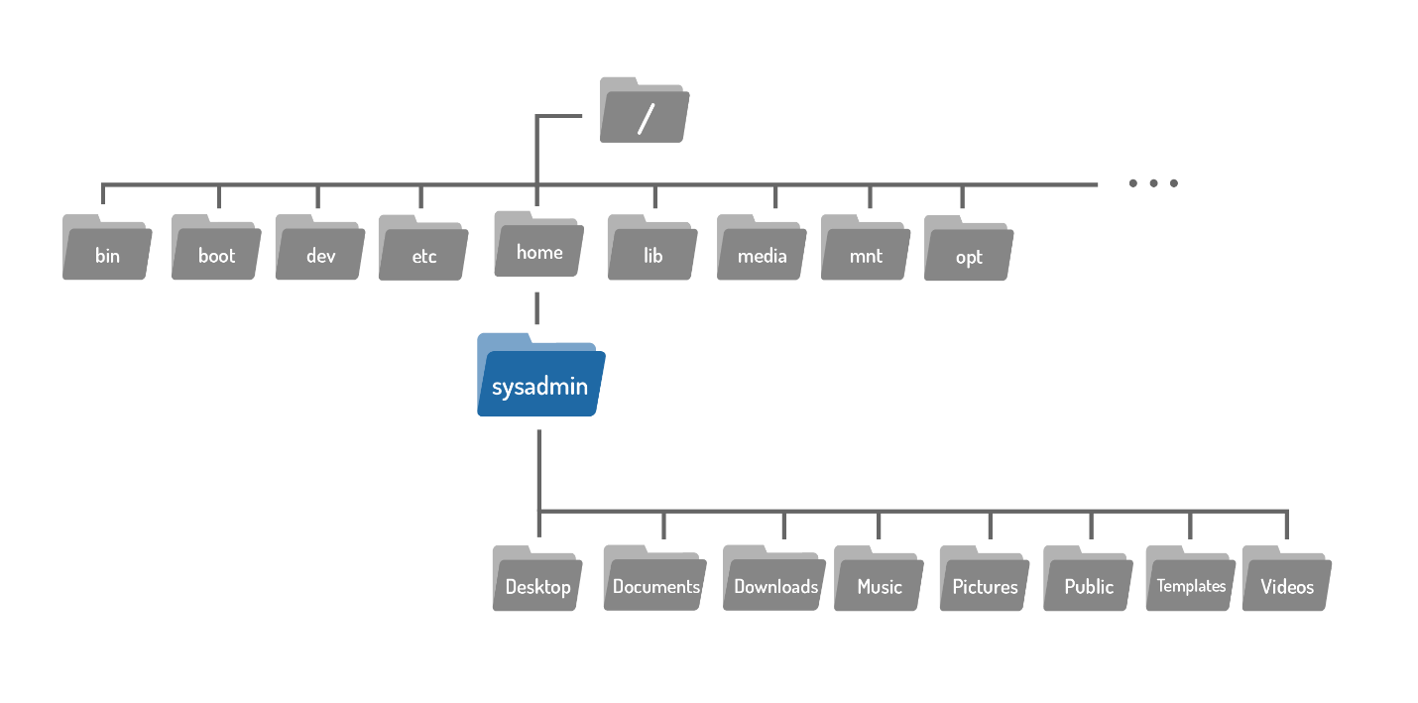

**Consider This**

Notice our virtual machines employ a prompt that displays the current working directory, emphasized with the color blue. In the first prompt above, the blue ~ is equivalent to /home/sysadmin, representing the user's home directory.

sysadmin@localhost**:~$**

After changing directories (we will learn how to do this in the next section), the new location can also be confirmed in the new prompt, again shown in blue.

sysadmin@localhost**:/etc/calendar$**



## Changing Directories

Files are used to store data such as text, graphics and programs. Directories are a type of file used to store other files–they provide a hierarchical organizational structure. The image below shows an abbreviated version of the filesystem structure on the virtual machines.

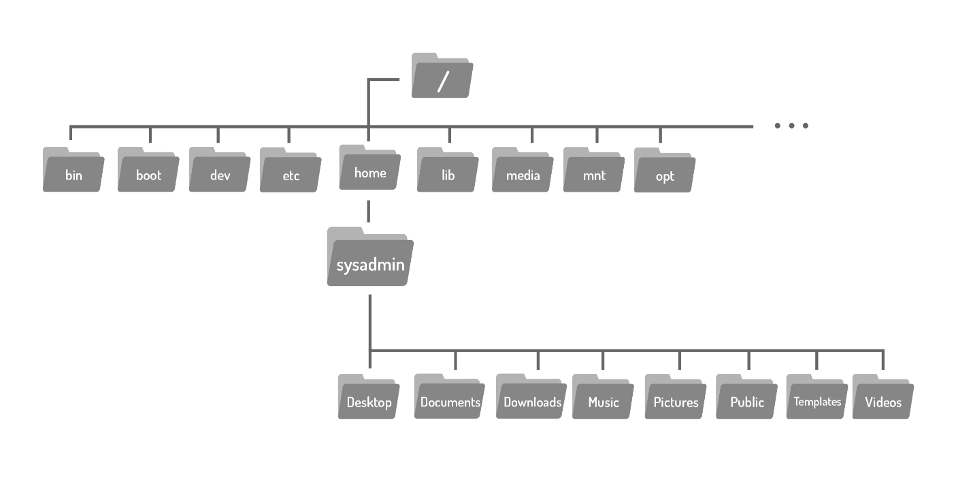

When you start a fresh virtual machine, either by opening the course or after using the reset button, you are logged in as the sysadmin user in your home directory, highlighted below:



To navigate the filesystem structure, use the cd (change directory) command to change directories.

cd [options] [path]

If you look back at the graphic above, you will see the Documents directory is located within the home directory, where you are currently located. To move to the Documents directory, use it as argument to the cd command:

sysadmin@localhost**:~$** cd Documents

sysadmin@localhost**:~/Documents$**

Directories are equivalent to folders on Windows and Mac OS. Like these more popular operating systems, a Linux directory structure has a top level. It is not called "My Computer", but rather the root directory and it is represented by the / character. To move to the root directory, use the / character as the argument to the cd command.

sysadmin@localhost**:~$** cd /

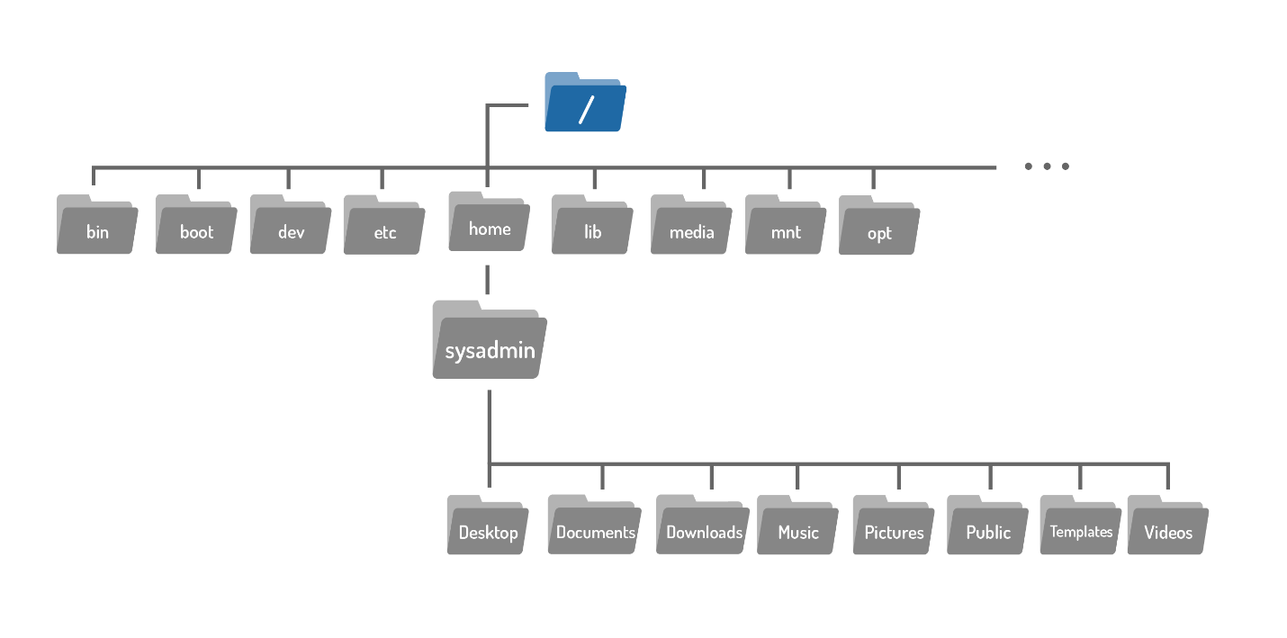

The argument to the cd command is more than just the name of a directory, it is actually a path. A path is a list of directories separated by the / character. For example, /home/sysadmin is the path to your home directory:

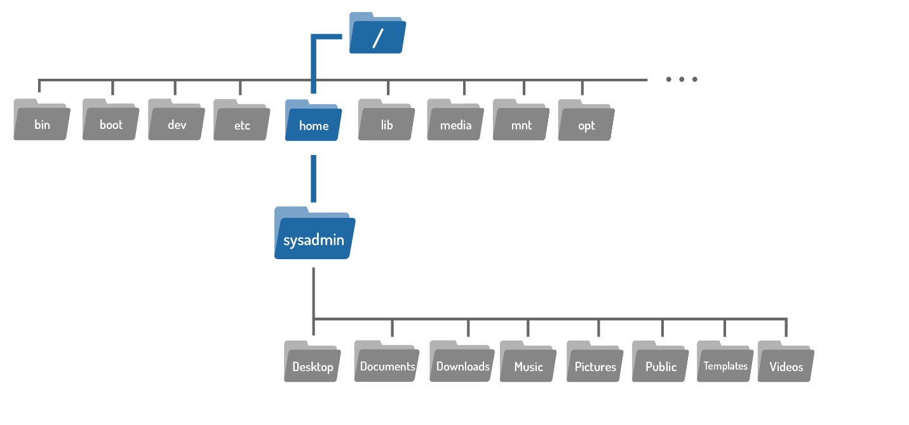

If you think of the filesystem as a map, paths are the step-by-step directions; they can be used to indicate the location of any file within the filesystem. There are two types of paths: absolute and relative. Absolute paths start at the root of the filesystem, relative paths start from your current location.